Kit List:
Winter Munros
The phrase “no such thing as bad weather, only the wrong clothing/equipment”, is an apt one for venturing into Scotland’s mountains in winter: it really does make all the difference!
CLOTHING:
- Good waterproof jacket and waterproof trousers/salopettes (not insulated ski-wear – too hot!) Gore-tex, eVent, etc are good, suitable fabrics. A jacket with a large hood that will fit over a helmet can help. It’s also definitely worth having waterproof trousers with long side zips that can be put on over boots/crampons.
- Comfortable non-restrictive trousers (synthetic material such as softshell is best)
- Wicking synthetic baselayer. I often take a spare on the hill each day, as I find changing my base layer after a particularly sweaty ascent can be a godsend for the rest of the day
- Thermal top and bottoms if you feel the cold
- Midlayer (e.g. fleece/softshell jacket)
- Some form of packable insulation: down for dry conditions, synthetic for wet (British!)
- Warm hat (at least x1)
- Buff (VERY useful item as extra hat/hand warmer/goggle-wiper/neck gaiter or faceguard)
- Gloves (I take a variety of thin and thick gloves – usually at least x3 pairs on the hill each day)
- Mittens (if it is especially cold, there is no better way to keep your hands warm)
- Gaiters (a great help, especially on the boggier walks or in snow!)

EQUIPMENT:
- Decent backpack: 30-40 litres is a good size, with some form of waterproof liner(s).
- Multiple drybags are FAR better than a raincover, both in waterproofing and keeping your contents organised. A raincover is also very likely to blow away in strong winds.
- Headtorch: essential (check batteries beforehand. 1 battery reversed inside the torch prevents accidental usage)
- Walking poles (broad-based snowbaskets can help in deep powder. “Flick-locks are better than “twist-locks”, which are prone to freezing and difficult to collapse). Best are the kind that stow away small enough to fit inside your sack
- Ski Goggles (if it is especially windy and snowy, these can really help your vision)
- Food – ensure it can be eaten with gloves on if necessary. I favour a sweet/savoury balance of around 50:50. And something really yum for morale boosts goes a long way!
- Water (a good quality water bottle is a worthwhile investment and ease of use trumps hydration bladders, which can easily freeze or burst)
- Flask for soup/hot drinks

FURTHER READING:
https://www.ellis-brigham.com/winter-hill-walking-kit-list
https://www.ellis-brigham.com/mountaineering-clothing-buying-guide

*N.B: in the interests of your own personal safety and well-being, Dubh Mor reserves the right to refuse to take participants on the hill if their personal clothing is deemed unsuitable and potentially dangerous. Should you have any queries regarding the suitability of your kit, please contact us prior to booking – we are happy to help and always eager to talk about kit!

THE “BIG THREE”: ESSENTIALS!

- Good *winter walking boots with ankle support and a decent tread, well-fitted and previously used. These will need to be “beefier” than summer boots and have a stiff sole (B2 or B3 rated) that will accept compatible crampons

FURTHER READING:
https://www.ellis-brigham.com/mountaineering-boot-buying-guide

- A *walking axe is usually straight-shafted, (between 50-70cm long is a good size), with an adze (not a hammer) so you can cut steps, etc. Taller people need larger axes than shorter people, but most first-time buyers purchase an axe too long for effective use. When used for balance, the axe is most often in the uphill hand – hence it needs to be much shorter than say, a walking pole. Likewise, too long an axe renders ice axe arrests difficult, if not dangerous. A longer axe also weighs more and is more tiring to swing, and to carry.
To size: stand up straight and allow the ice axe to hang from your hand. With the flat of the handle resting against your palm, the head of the ice axe should reach the middle of your calf, above your boot top. (See below)

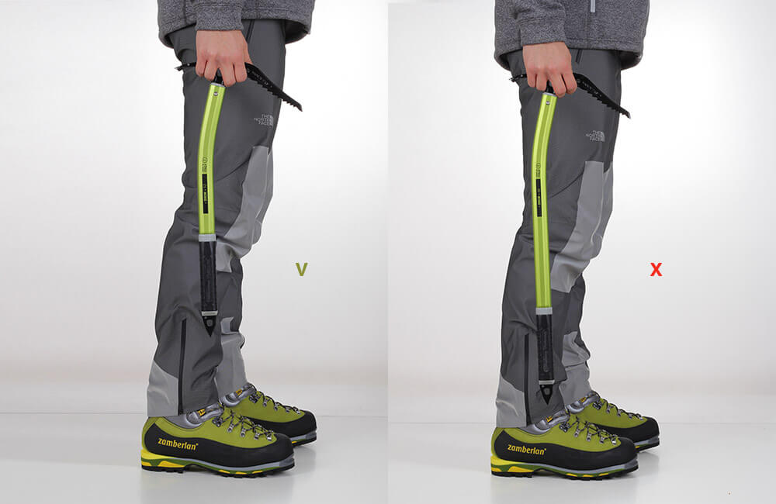
Correct Too long
What type of axe? For this course we recommend a single walking axe as the best choice. A very basic, fairly straight-shafted walking/hybrid style axe will work best. Technical climbing axes will be more hinderance then help, and are not recommended.
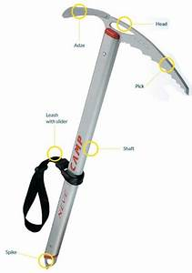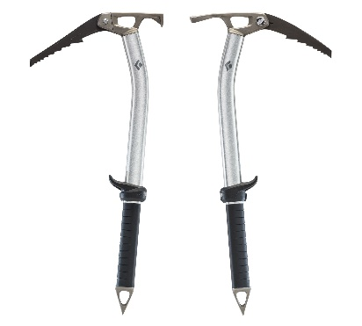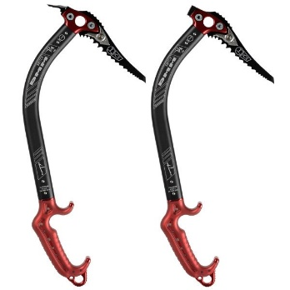
Walking Axe | Hybrid / Alpine Axes | Technical Climbing Axes
-For walking only, not climbing | -For walking/ mountaineering/climbing | -For climbing/mountaineering

FURTHER READING:
https://www.ellis-brigham.com/ice-axes-buying-guide#alpine-ice-axes

- *Walking crampons (fitted to your boots BEFORE going onto the hill). Essentially there are 3 tiers of crampon (see below). For this course, go for something solid but simple in the winter walking category (C1), or in the general mountaineering genre (C2) if you want to “future-proof” them and allow later progression. Front points will also help when ascending steep snow slopes. Technical climbing crampons (C3) will not be suitable due to their stiffness. Non-rated, recreational “overshoe”-type crampons designed for icy pavements are not suitable for this course.

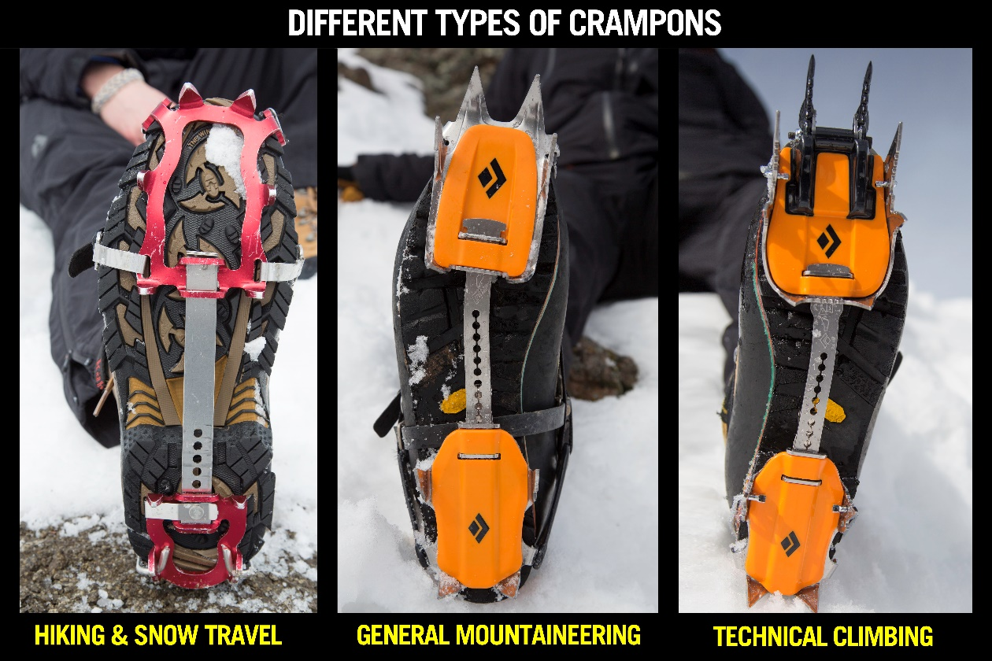

Crampon Rating | C1 | C2 | C3
Compatible with: | B1/B2/B3 boots | B2/B3 boots | B3 boots only
Front points: | No | Horizontal, fixed | Vertical, often replaceable/ interchangeable dual/mono
# points: | 10 | 12 | 12/14
Feel: | Flexible | Stiff | Solid
Fittings: | Flexible heel and toe cradle | Plastic heel lock, flexible toe cradle | Plastic heel lock, metal bail

FURTHER READING:
https://www.ellis-brigham.com/crampons/crampons-buying-guide

